CURRICULUM VITAE

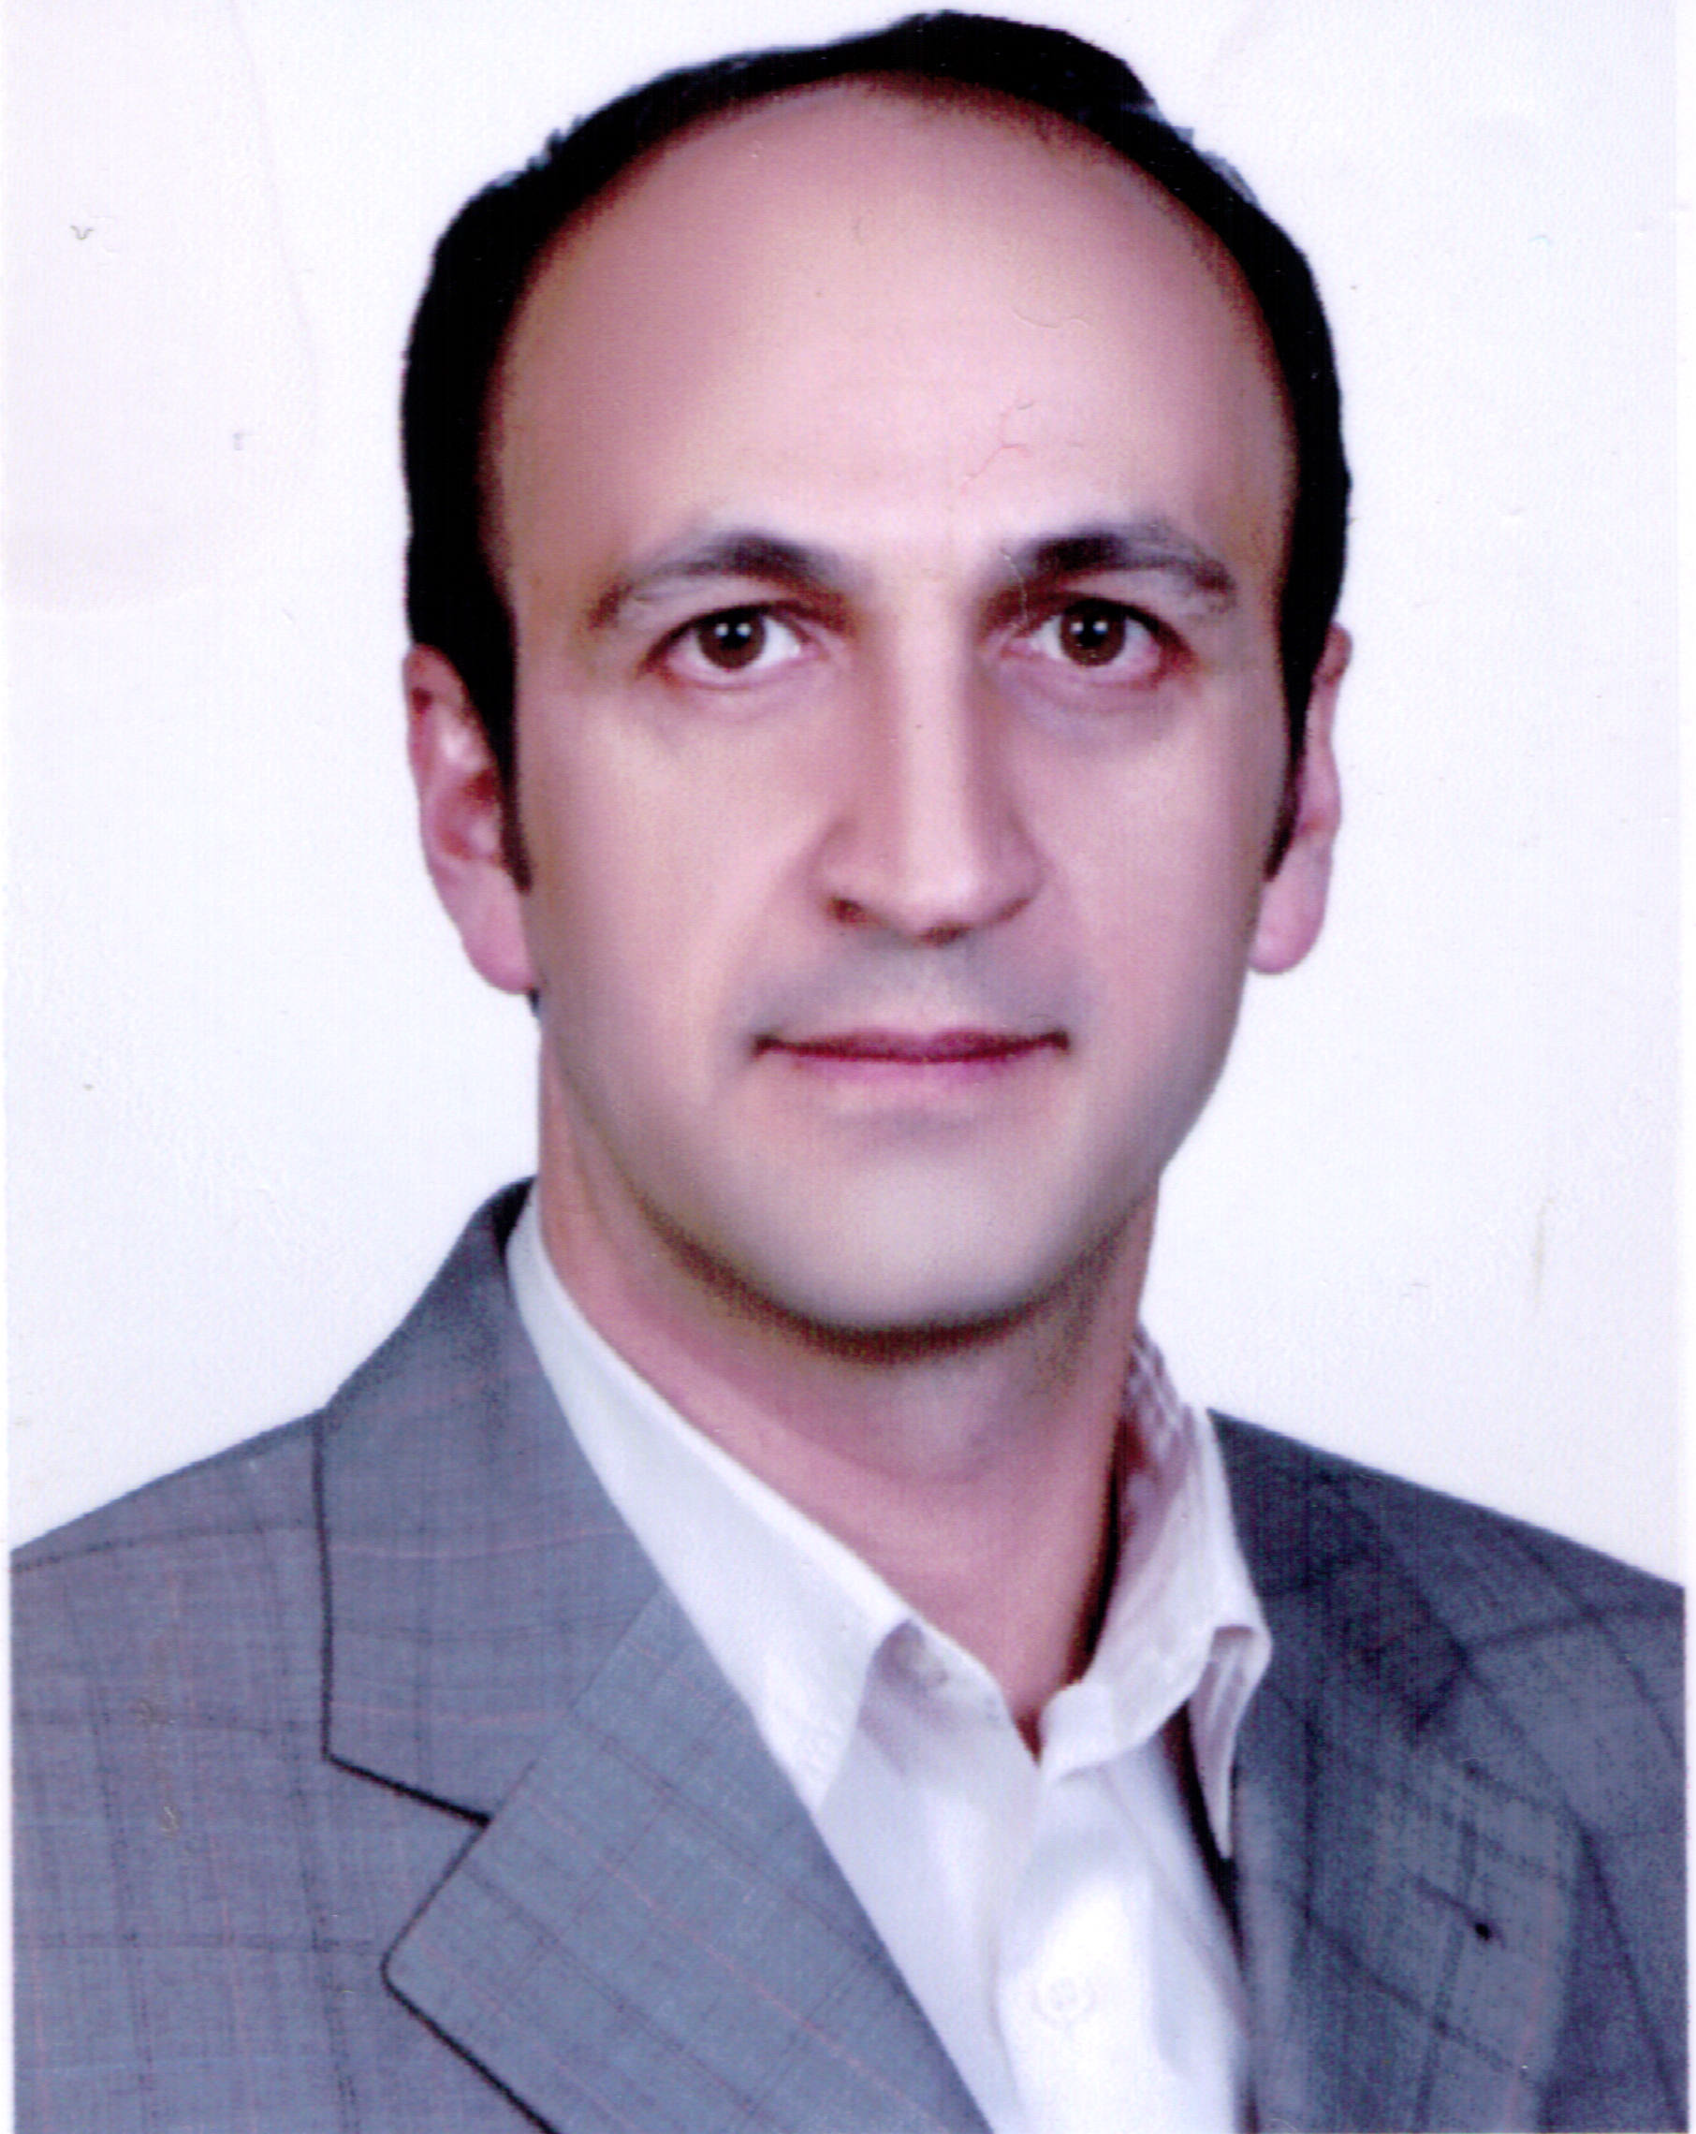

- General information :

MALING ADDRESS: Tabriz University Hematology & oncology Research Center, Shahid Ghazi Hematology & oncology Ward, Imam Hospital, Tabriz University of Medical Sciences

Tel : +98 0411 3343811-13
Fax: +98 0411 3343844
E-mail: ali_sfhn@yahoo.com

Date of Birth: 20/3/1964
Place of Birth: hamedan-Iran
Marital Status: Married
Citizenship: Iran

- Languages:
English -Farsi

- Education :
General medicine : Shiraz university of medical science(1986-1993)

Internal medicine : Ahvaz university of medical science(1997-2001)

Hematology Oncology : Tehran university of medical science(2002-2005)

- Professional Employment History:
General practitioner : hamedan university of medical science(1993-1997)
Internist : ahvaz university of medican science, imam Ali hospital
Hematolosist-onocologist : Tabriz university of medical science(since nov 2005)

- Honors:
10th grade in Internal MedicineBoard Examination in IRAN(2000)

- Board Certification:
Certification of Internal Medicine ,sep 22, 2001
Certification of Hemato-oncology sep 22, 2005

Medical License:

- CURRENT DUTIES:

Medical Director:

Research:

Education:

TEACHING :
Classroom Instruction :

Clinical Instruction:

COMMITTEES:

▪Member of Iranian Society of hemato-oncology.
▪Member of Iranian Society of bone marrow transplantation.
▪Member of Hematology and oncology research center of Tabriz University Medical Sciences.
▪Member of cancer control of east azarbijan

Department Committees:

Hospital Committees:
Tabriz University of Medical Science Haematology&Oncology Research Center

MENTORSHIP:
Doctoral Thesis Committee Member:
 | name |  | Date
1
2
3
4
5
6
7
8
9
10

Research Projects:
1- Effects of Chemotherapeutic agents on antioxidant status in patients with acute myelogenous leukemia

PUBLICATIONS:

Abstracts:
- Esfahani A, Iravani M. Bone lossand gonadal function after bone marrow transplantation-prospective study. 2006 BMT Tandem Meeting, Feb. 16-20, Hawaii Convention Center Honolulu, Hawaii, USA (poster No:313).
- Ghoreishi Z, Shifar F, Iravani M, Esfahani A. Effect of vitamin E on complications of chemotherapy in leukemic patients undergoing bone marrow transplantation. 9th Nutrition Congress of Iran, Tabriz.Sep.4-6 2006

LECTURES, SPEECHES AT PROFESSIONAL CONFERENCE/MEETINGS:

1- Ovarian and uterian cancer conference. May 12th 2006.
2- Colorectal cancer conference. Nov 29th 2006.
3- Lung cancer conference. March 7th 2007.
4- Non Hodgkin lymphoma conference. April 12th 2007.
5- Laryngeal cancer conference. May 30th 2007.
6- hematologic malignancies. Dec 5 2007.

Participation in Workshops:

1-breast cancer .Tehran University of Medical Science, Apr, 2002.

2-2th international congress on advanced in hematology and oncology and bone marrow transplantation ,Tehran ,Iran, Tehran university of Medical Science,sep,2002.

3- One-Day Symposium of Oxaliplatin, 27 Feb 2003, Azadi Hotel Tehran.

4-9th Asian pacific Bone marrow transplantation congress, Tehran, Iran, Tehran university of Medical Science, Nov 2004.

5-4th Iranian Hemato-oncology congress, Mashhad, Iran, Mashhad university of Medical Science, Jun 2004.

6-diagnosis and treatment of gastric cancer, Tehran, Iran, Tehran university of Medical Science, Feb, 2005.

7-new diagnosis and treatment NHL, Tehran, Iran, Tehran university of Medical Science, Jul, 2005.

8- One-Day Conference of Head and Neck Tumors for ENT specialists, Radiotherapists and Hematology & Oncologists,12 Jan 2006, Pars Hotel ,Tabriz.

9-head and neck tumor. Tabriz, Iran, Tabriz university of Medical Science, Jan, 2006.

10-MCQS, Tabriz, Iran, Tabriz university of Medical Science, Apr, 2006.

11-Role of endocrine therapy in breast cancer, Tehran, Iran, Tehran university of Medical Science, jul, 2006.

Journal Articles

1-Mowla K, Esfahani A. Determination of bone mineral density in systemic lupus erythematosus patients referred to rheumatology clinic of ahvaz university of medical science. Sci,Med. J.,No. 36 Jun 2003, p:38-43.

2-Esfahani A, Iravani M, khoshniat M. Bone densitometric change after bone marrow transplantation in 63 patients with leukemia and lymphoma Tehran University Medical Journal; Vol. 65, No. 5, Aug 2007: _25-32.

3-Ghoreishi Z, Shidfar F, Iravani M, Esfahani A. Effect of vitamin E on chemotherapy-induced mucositis and neutropenia in leukemic patients undergoing bone marrow transplantation. APJO, Vol 3, issue 3, 28 sep 2007.

4-Effect of vitamin E on chemotherapy – induced mucositis and neutropenia in leukemic patients undergoing bone marrow transplantation, zohreh ghoreishi1,*,farzad shidfar1, Masoud iravani2, ali esfahani2 andArdeshir ghavamzadeh2, Asia-Pacific Journal of Clinical Oncology,Volume 3, Issue 3, pages 113–118, September 2007.

5- Arsenic Trioxide in patients with refractory multiple myeloma: A prospective , phase II, single arm study. Sanaat Z, Rezazadeh M.,Vaez J., Eivazi Ziae J., Esfahani A. Acta Medica Iranica, 2011,Vol 49, No 8, P:504-8.

6- Effects of Music Therapy on Pain and Anxiety in Patients Undergoing Bone Marrow Biopsy and Aspiration, Shabanloei R1, Golchin M, Esfahani A, Dolatkhah R, Rasoulian M, AORN J. 2010 Jun;91(6):746-51.

7- Clinical use of haemate-P in inheriated von Willebrand s disease: a patient with type 3 VWD and recurrent menometerorrhagia, R. DOLATKHAH, I. A. KERMANI, Z. SANAAT, S. SEIFI, J. E. ZIAEI, A. NIKANFAR, A. ESFEHANI andS. H. CHAVOUSHI, Haemophilia 2010,Volume 16, Issue 3, pages 555–557, May 2010.

8- Assessment of oxidative stress in acute myeloid leukemia, Ali Esfahani MD.1*Zohreh Ghoreishi MSc.2 Alireza Nikanfar MD.1 Zohreh Sanaat MD.1 Amir Ghorbanihaghjo PhD.3 Nadereh Rashtchizadeh PhD. Tehran University Medical Journal; Vol. 68, No. 11, Feb 2011: 649-655.

9- Arsenic Trioxide in patients with refractory multiple myeloma: A prospective , phase II, single arm study. Sanaat Z, Rezazadeh M.,Vaez J., Eivazi Ziae J., Esfahani A. Acta Medica Iranica, 2011,Vol 49, No 8, P:504-8.

10- Evaluation of Copper, Zinc, Cu/Zn, and VEGF in Patients with AML in Iran, Sanaat, M Nouri, B Hajipour, R Dolatkhah, I Asvadi, J Vaez, J Eivazi, A Nikanfar, A Esfahani, Sh Chavoshi, H Biorani, Vol 4, No 4, Autumn 2011.

11- Age pattern of the occurrence of Breast Cancer in the north west of iran, Eivazi-Ziaei J, Dastgiri S, Kermani I A, Nikanfar A, Esfahani A, Sanaat Z, Sadeghi-Bazargani H, Vaez J, BREAST - ORIGINAL ARTICLE

Year : 2011 | Volume : 48 | Issue : 4 | Page : 406-409.

12-Influence of Chemotherapy on the Lipid Peroxidation and Antioxidant Status in Patients with Acute Myeloid Leukemia, Ali Esfahani1, Zohreh Ghoreishi2, Alireza Nikanfar1, Zohreh Sanaat1, and Amir Ghorbanihag, Acta Medica Iranica, 2012; 5(7): 454-458.

13-Omega-3 fatty acids are protective against paclitaxel-induced peripheral neuropathy:A randomized double-blind placebo controlled trial, Zohreh Ghoreishi1, Ali Esfahani2, Abolghasem Djazayeri1, Mahmoud Djalali1, Banafsheh Golestan3,Hormoz Ayromlou4, Shahriar Hashemzade5, Mohammad Asghari Jafarabadi6, Vahid Montazeri5,Seyed Ali Keshavarz1*and Masoud Darabi7, Ghoreishi et al. BMC Cancer 2012, 12:355.

14- Pharmacy Students' Self-Identified Interests in a Hospital Pharmacy Internship Course in Iran, Simin Mashayekhi1,2*, Mohammad Reza Sattari2,3, Nasrin Maleki-Dizaji2, Masoud Asadi4, Mina Islamboulchilar4, Alireza Parvizpour2, Mahasti Alizadeh1,5, Ali Esfahani3,5, Mohammad Reza Ardalan5, Mohammad Hossein Soumi5,6, Mehdi Farhoodi5,7, Fatemeh Ranjbar5,7, Mojtaba Varshochi5,8, Hadi Hamishehkar2,

Res Dev Med Educ, 2012, 1(2), 49-53.

15- Successful Management of Total Knee Replacement in a High Responder Hemophilia Patient With a History of Inhibitor, Roya Dolatkhah 1, Mohammad Reza Bazavar 2, *, Masoud Poureisa 3, Iraj Asvadi Kermani 1, Jalil Vaez Gharamaleki 1, Zohreh Sanaat 1, Jamal Eivazi Ziaei 1, Alireza Nikanfar 1, Ali Esfahani1, Seyed Hadi Chavoshi 1, Iran Red Crescent Med J. 2013:15(1).

16- Immunohistochemical Analysis of p53, Ki-67, CD44, HER-2/neu expression Patterns in Gastric Cancer, and their association with one-year survival in North-West of Iran, ohreh Sanaat*, Monireh Halimi, Morteza Ghojezadeh, Amir Hossein Pirovi, Jalil Vaez Gharamaleki, Ali Esfahani Jamal Eivazi Ziae, Iraj Aswadi Kermani, IJHOSCR 7(3) - ijhoscr.tums.ac.ir – July 1, 2013.

17- Delayed hemolytic transfusion reaction with multiple alloantibody (Anti S, N, K) and a monospecific autoanti-JKb in intermediate β-thalassemia patient in Tabriz Roya Dolatkhah, Ali Esfahani1, Seyed Esmaeil Torabi2, Iraj Asvadi Kermani1, Zohreh Sanaat1, Jamal Eivazei Ziaei1, Alireza Nikanfar1, Seyed Hadi Chavoshi1,Zohreh Ghoreishi1, Atabak Asvadi Kermani1, Asian Journal of Transfusion Science - Vol 7, Issue 2, July - December 2013.

18- Evaluating the epidermal growth factor receptor in non small cell carcinoma of lung according to the grade

of tumor and cellular differentiation, Ashraf Fakhrjou 1, Ali Esfehani 1, Iraj Asvadi1. Hiva Moein1, Morteza Ghojazadeh1, Journal of American Science 2013;9(11).

19- siRNA-mediated Silencing of Survivin Inhibits Proliferation and Enhances Etoposide Chemosensitivity in Acute Myeloid Leukemia Cells, Hadi Karami1,2, Behzad Baradaran1*, Ali Esfahani3, Mehrdad Asghari Estiar4, Mohammad Naghavi-Behzad5, Masoud Sakhinia6, Ebrahim Sakhinia7*, Asian Pac J Cancer Prev, 14 (12), 7719-7724.

20- Down-regulation of Mcl-1 by small interference RNA induces apoptosis and sensitizes HL-60 leukemia cells to etoposide, Karami H1, Baradaran B, Esfehani A, Sakhinia M, Sakhinia E, Asian Pac J Cancer Prev. 2014;15(2):629-35.

21- Financial Distress and its Predicting Factors among Iranian Cancer Patients, Abazar Fathollahzade1, Azad Rahmani2*, Abbas Dadashzadeh1, Akram Gahramanian1, Ali Esfahani2, Leila Javanganji2, Leila Nabiolahi1, Asian Pac J Cancer Prev, 16 (4), 1621-1625.

22- Effect of Beta Glucan on Quality of Life in Women with Breast Cancer Undergoing Chemotherapy: A Randomized Double-Blind Placebo-Controlled Clinical Trial, Alireza Ostadrahimi1, Ali Esfahani2, Mohammad Asghari Jafarabadi3, Jamal Eivazi Ziaei2, Aliakbar Movassaghpourakbari2, Nazila Farrin4*, Adv Pharm Bull, 2014, 4(Supp1), 471-477.

23)Effect of Beta Glucan on White Blood Cell Counts and Serum Levels of IL-4 and IL-12 in Women with Breast Cancer Undergoing Chemotherapy: A Randomized Double-Blind

Placebo-Controlled Clinical Trial, Alireza Ostadrahimi1, Jamal Eivazi Ziaei2, Ali Esfahani2, Mohammad Asghari Jafarabadi3, Aliakbar Movassaghpourakbari2, Nazila Farrin4* , Asian Pac J Cancer Prev,2014, 15 (14), 5733-5739.

24- Effect of Taurine on Febrile Episodes in Acute Lymphoblastic Leukemia Mina Islambulchilar, 1 Iraj Asvadi, 2 Zohreh Sanaat, 2 Ali Esfahani, 2 and Mohammadreza Sattari 2 , Adv Pharm Bull. 2015 Mar; 5(1): 103–108.

25- Taurine attenuates chemotherapy-induced nausea and vomiting in acute lymphoblastic leukemia, Mina Islambulchilar · Iraj Asvadi · Zohreh Sanaat ·Ali Esfahani · Mohammadreza Sattari, oct 2014.

26- Reliability Evaluation of Fluorescence In Situ ybridization (FISH) and G-Banding on Bone Marrow and Peripheral Blood Cells in Chronic Myelogenous Leukemia Patients, Soheila Manaflouyan Khajehmarjany, M.Sc.1, 2, Seyed Ali Rahmani, Ph.D.1, 2*, Seyed Hadi Chavoshi, M.D.3, 4, Ali Esfahani, M.D.3, 4, Ali Akbar Movassaghpour Akbari, Ph.D.3, 4,

CELL JOURNAL(Yakhteh), Vol 17, No 1, Spring 2015.
Medical & Extra medical Interests:
Acute and chronic leukemia
GI cancer
Multiple myeloma
Hemolytic anemia

